|  |  |  |  |  |  |
| --- | --- | --- | --- | --- | --- |
| Cover Sheet | | | | |  |
| STUDENT NAME | | | | | STUDENT NUMBER |
| POSTAL ADDRESS | | | | | |
| POSTCODE | | PHONE | | | |
| EMAIL | | | | | |
| UNIT NAME  **Software Engineering Process and Tools** | | | | | |
| UNIT CODE  **PRT-452** | | | | | **Semester _2____**  **Year ___2017___** |
| LECTURER NAME | | | | |
| ASSESSMENT TITLE  Project report - | | | | |
| DUE DATE | DATE OF SUBMISSION | | | APPLIED FOR EXTENSION? ⬜YES ⬛NO ⬜N/A | |
| **KEEP A COPY**  If you have submitted assessment work electronically please make sure you have a backup copy.  **PLAGIARISM**  Plagiarism is the presentation of the work of another without acknowledgement. Students may use a limited amount of information and ideas expressed by others but this use must be identified by appropriate referencing.  **CONSEQUENCES OF PLAGIARISM**  Plagiarism is misconduct as defined under the Student Conduct By-Laws. The penalties associated with plagiarism are designed to impose sanctions on offenders that reflect the seriousness of the University’s commitment to academic integrity. | | | | | |
| I declare that all material in this assessment is my own work except where there is a clear acknowledgement and reference to the work of others. I have read the University’s Academic and Scientific Misconduct Policy and understand its implications.* *http://www.cdu.edu.au/governance/documents/3.3academicandscientificmisconduct.doc*  Signed: ________________________________________________ Date: ___________________________  *\*By submitting this assignment and cover sheet electronically, in whatever form you are deemed to have made the declaration set out above.* | | | | | |
| **Office use only** | | | **Assessor use only** | | |
| DATE RECEIVED | | | PLEASE PLACE GRADE HERE | | |
| DATE SENT TO LECTURER | | |

**Acknowledgement**

Team would like to express special gratitude towards our Client Mr. Siva Vellavani who showed a confidence on our abilities and gave us opportunity to work on his idea. His constant feedback on our work helped us a lot to improve the final outcome.

We are greatful towards our coordinator Dr. Peter Shaw, who enlightened our path towards knowledge and information. Dr. Peter was continues source of support and knowledge and his guidance helped the entire team to complete the project on time.

**History of Game theory**

Game theory is the study of mathematics model and is mainly used in psychology, political science, economics, computer science and biology. Gmae theory began with the idea regarding the existence of mixed strategy equilibria in two person zero sum games and itsproof by John von Neumann. Game theory is the study of human conflict and cooperation within a competitive situation. In some respects, game theory is the science of strategy, or at least the optimal decision-making of independent and competing actors in a strategic setting. The key pioneers of game theory were mathematicians John von Neumann and John Nash, as well as economist Oskar Morgenstern.

Game theory creates a language and formal structure of analysis for making logical decisions in competitive environments. The term “game” can be misleading. Even though game theory applies to recreational games, the concept of “game” simply means any interactive situation in which independent actors share more-or-less formal rules and consequences.

The formal application of game theory requires knowledge of the following details: the identity of independent actors, their preferences, what they know, which strategic acts they are allowed to make, and how each decision influences the outcome of the game. Depending on the model, various other requirements or assumptions may be necessary. Finally, each independent actor is assumed to be rational.

# Project Information

## Project Overview

Random Patrolling is an android application. With this application the user is able to locate his/her next station to visit. This application helps the user which station to visit next, total number of station to visit within the given time, number of times he/she have to visit the station in the allocated time. This application is based on travelling sales person algorithm which generates the routes based upon the shortest distance between the stations. The application regenerates the route if there is alert in between.

## Purpose of the project

This project is designed for those who want to visit the different places with certain time limitation and do their work. With the help of this project one can find the shortest distance between their stations. The main purpose of this project is that the user can find the shortest routes between the stations and can find the route to the station through the Google map inbuilt in the application. The guidelines like the number of station he/she have to visit in his working time, number of visits in each station, minimum and maximum time one has to spent in each station is provided in the application. The admin or the organization is allowed to add all the above information and the user can view it through his login credential. If some obstacles occurs in between his route like some alarm occurs in some station and required the immediate present of the user then according to his location the path reroutes automatically based upon his visit history on the vary day.

## Objective and Goals

The objective of completing this project is to learn about various software development process and the challenge and obstacles one can face during the development of application. After the successful completion of the project one can learn following things.

* To analyse and examine the process involved software system engineering.
* To build the computer solution for real life based problems.
* To conduct a series of test on software at various levels.
* To evaluate testing methodologies critically through research reports.
* To develop the personal skills and find the way to mingle with the group members of software engineering teams.

# Requirement

## 2.1 Functional Requirement

Function requirements are requirements which show the functionality of the application. Functionality and service which are provided by application in order to meet user requirement is called functional requirements.

* Application should allow user to login using their credential.
* User should be able to add places and view the places they have added.
* After the number of station finalized user must be able to see the places they have to visit in the Google map with the direction.
* After visiting the certain station they can push up the message that they have visited it.
* They can push the alert alarm if they find anything suspicious and thinks it need to be taken an extra care.

## 2.2 Non Functional Requirement

The requirement that improves the user flexibility to use the application is known as non functional requirement.

* Our application runs on android version on or above API 19 (Android 4.4 Kitkat).
* The login secures the user data and that can only be viewed by them.
* The application open in about 3 to 4 seconds.
* The user interface is user friendly and can be easily used by the user withour any difficulties.

# UI Design

The Various windows of our app are listed below.

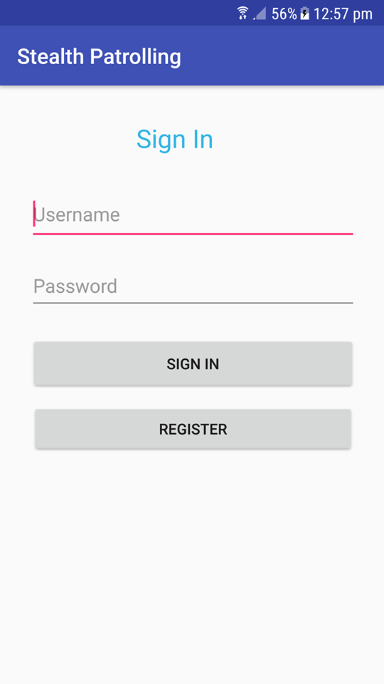

Fig: Login Window

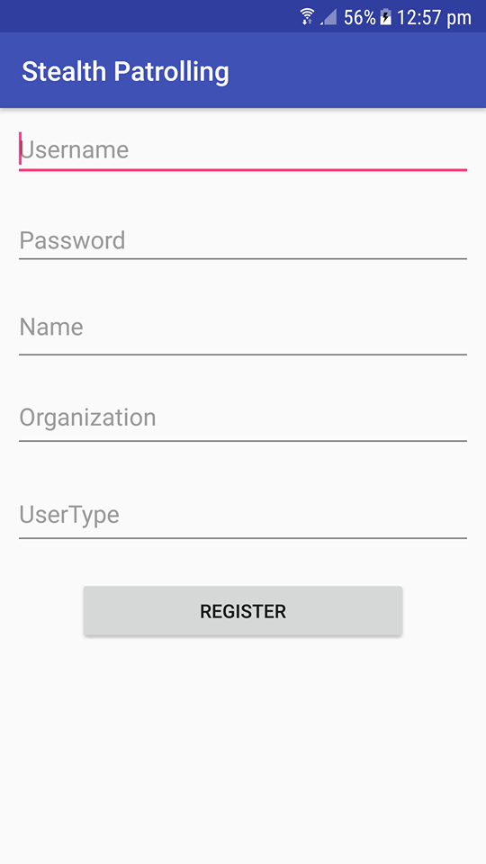

Fig: Registration Window

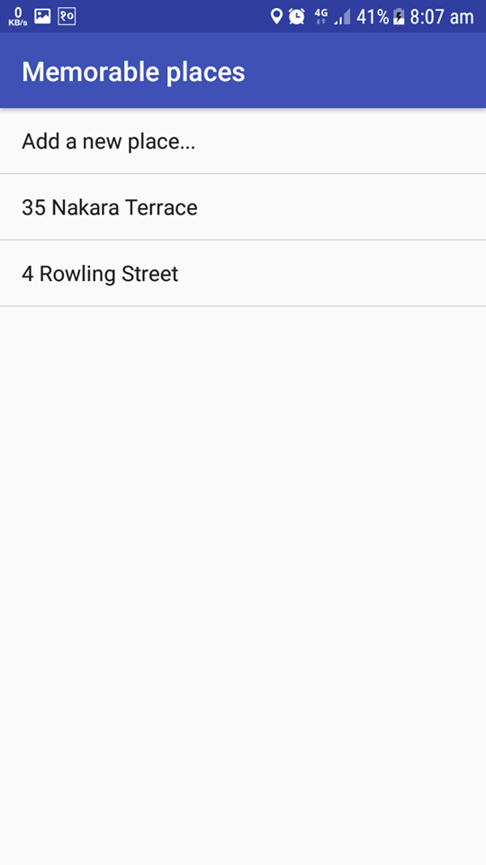

Fig: Add Places Window

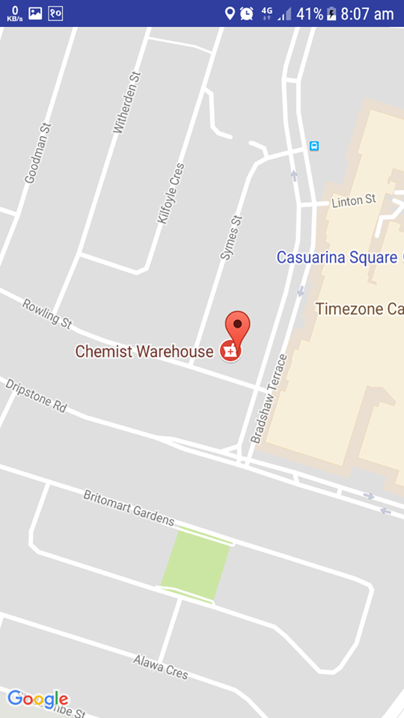

Fig: Destination

# Database Design

# UML Design

## Use Case Diagram

Use Case Diagrams is also referred as behaviour diagrams and it describes a set of actions that a system or user of that system can perform alone or with the collaboration of another external user. In our application a user can login into the app with the login credential. After the user logins he can perform a set of actions like adding places that are to be visited, view the places that are added and the shortest route to visit those places. The routes will be shown on the Google map.

User

Fig: Use Case Diagram

## Sequence Diagram

Sequence diagrams are also known as event diagrams or event scenarios. This diagram shows that how an object operates with another object and in which sequence. The flow of the application or project in the continuous flow is shown through sequence diagram. In our project at first the user enters into the app by logging into it. The username and password is checked into the database. If not matched then the username and password not matched message is displayed in pop up. If matched then the user will add the places he/she have to visit. These places are saved into the database. Then the user can view the places added and routes to visit those places.

Database

User

Application

Verify

Login

Display correct or incorrect

Update Database

Add Places

Retrieve Data

View Places

Show Added Places

View Routes

Generate Route

Update Database

Fig: Sequence Diagram

## C) Activity Diagram

Start

End

Generate all possible routes

Read Coordinates

Open Selected location

Add places

Location list view

Enter login and password

Correct login or password?

No

Yes

Fig: Activity Diagram

# Testing

# TDD

# Change Management

# Config Management

# CI

# System Building

# Design Pattern

# Pair Programming

In this case, we decide to try pair programming during the development stage. We choose two programmers to work together, one is skilful and another is less.

However, at the beginning stage of programming, they argue for a long time instead of programming, but this situation disappeared after they start to program. One of them observed and gave ideas when another one was programming. Although, sometimes they were not in the same track, but after a short discussion, everything went well again.

The position of programmer and observer always change in order to keep the efficiency and one of them can take a break. But generally speaking, it is really exhausting after a day of development.

To sum up, pair programming seems inefficient and it really difficult to judge it is true or not, but the software does run well and we did not see any bug for now and also, both of the programmers did learn new knowledge in this case.

# Story Card

# Artificials

# Agile Process

Agile Software Development is relatively new term and it is very different from traditional development techniques. Agile methodology put more focus on methods of change management and less on up-front plans based approach. The main idea behind agile development is to highlight and accelerate the actions on evolving environments, achieving the deadlines and requirements (Rao et al. 2011).

It is a set of tools and techniques which are based on iterative and incremental approach. In agile, the requirements and solutions are evolved by thorough collaboration between self organizing and self functioning teams (Rao et al. 2011). Client is also a very crucial part of the development team and regular communication is maintained and continuous feedback is absorbed.

The companies and professionals in IT sectors prefer agile development methodology due to the fact that it provides improved communication between the team members, quick release of the product and flexibility in the designs. The development team varies between 2-20 and large companies like Microsoft and other big companies vary their agile team according to the project requirements (Begel & Nagappan nd).

Agile teams are group of multi-skilled professionals and product customers having significant knowledge of the domain. Numerous short and swift development iterations are conducted to accommodate the changes described by the client. It promote micro product map to establish a more precise project millstones.

# Security

Our application asks for the username and password in order to login. If the username and password is not matched then the user is denied the further access.

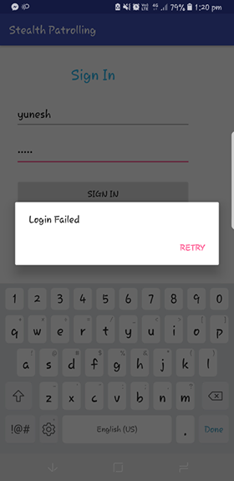

Fig: Unsuccessful Login

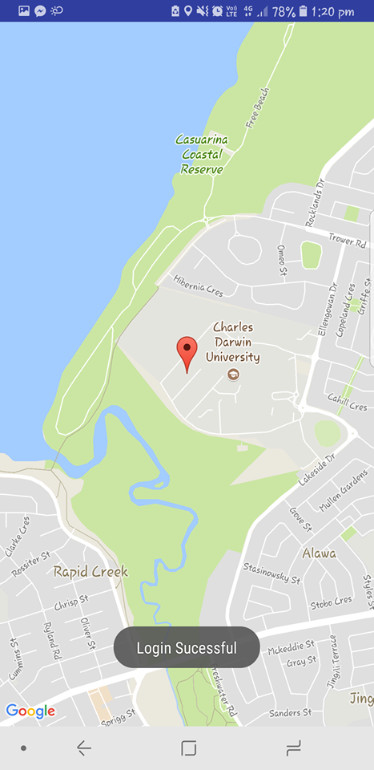

Fig: Successful Login

## Handling User Data

In general, the best approach for user data security is to minimize the use of APIs that access sensitive or personal user data. The user data is stored in our app only until the task is performed. After the task is completed then the user data is automatically removed from the database. This reduces the chances of inadvertently exposing the data, and it also reduces the chance of attackers attempting to exploit our application.

## Handling User Credential

Asking the user to use their authentication credential continuously will prone to the phishing attack. Instead of asking their login credential frequently, in our app we ask the user to login once and store those credential in our cloud based database and use the token to give them access. For this we have used AccountManager class which provokes the database automatically and verify the user. We have used CREATOR before passing credential so that our app does not pass the credential to any external source. Since the credential is used only by our app we have used checkSignature() method to verify that the application accesses the AccountManager.

# Code

# Documentation